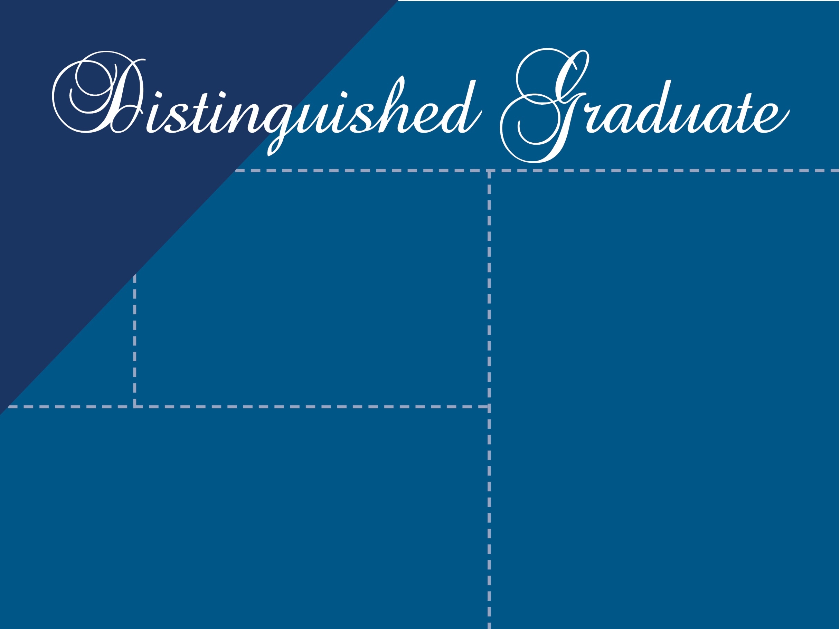

Jane Doe
School District
Awards
University Graduated
Impact Statement

“Quote from graduate about his/her
Experience in School of Education
program”

