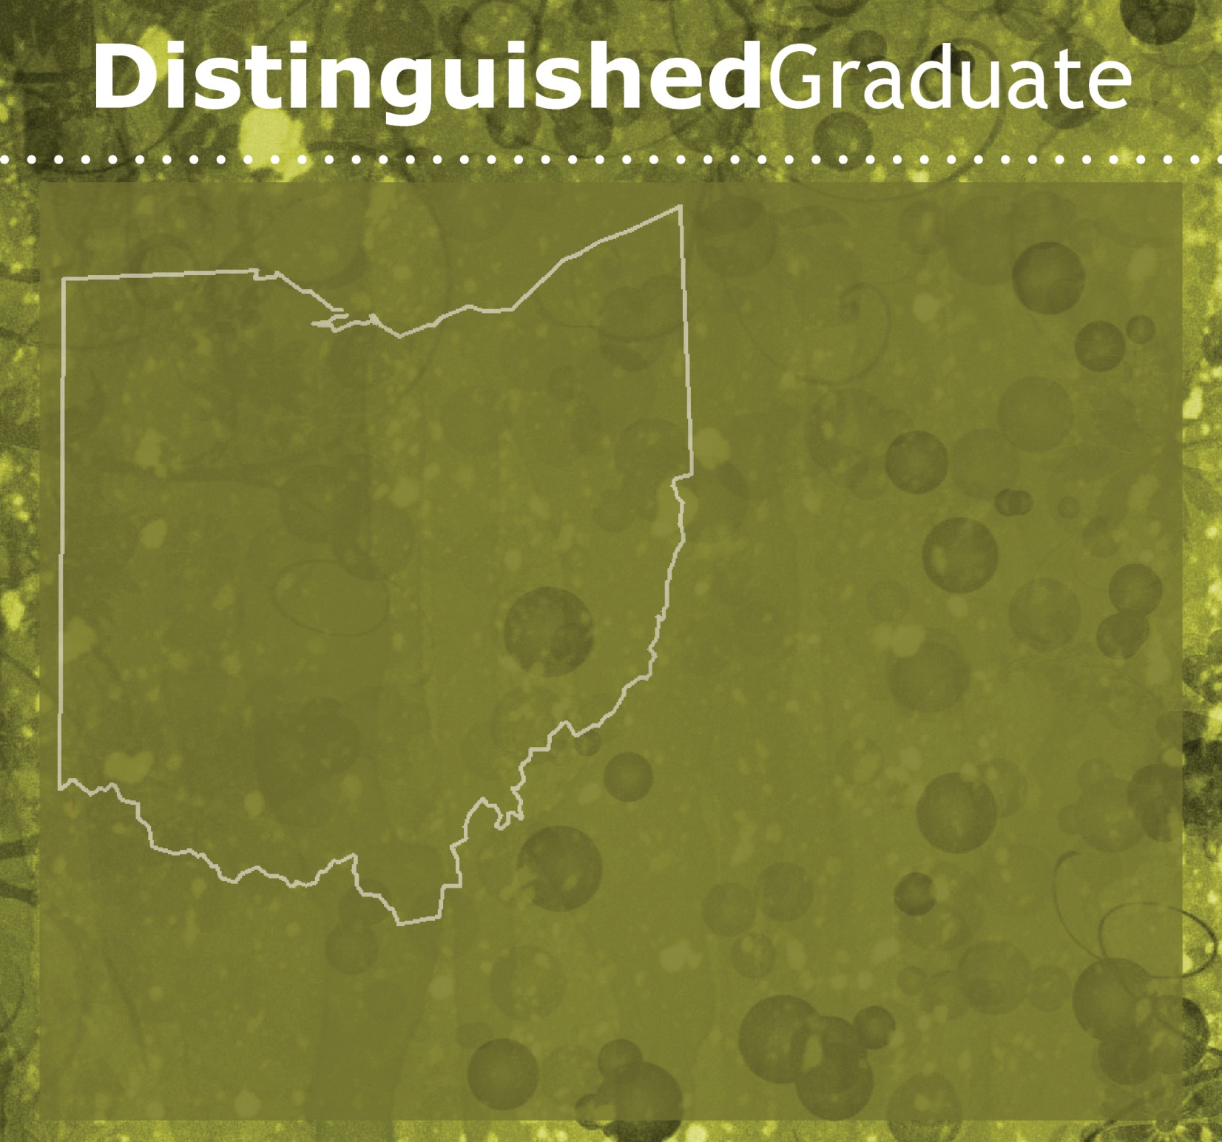

Jane Doe
School District
Awards
University Graduated
Impact Statement

“Quote from graduate about her/his experience in School of Education program”

